**Quarterly CRAFT Report**

**9/30/2022 Report**

*Quarterly Report Due Dates -*

*9/30/22, 11/1/22 (Final Pilot Report - Pilot Project Only), 12/30/22, 3/31/23, 5/1/23*

**Project Name: Fast Quantum Methods for Financial Risk Management**

**Institution Name: Stevens Institute of Technology**

**PI Name: Zhenyu Cui**

**CoPI/s Name/s: Rupak Chatterjee, Chihoon Lee**

**Team Member Names: Zhiyang Deng**

# **Deliverables**

Formulate practically important portfolio analysis problems, and translate into a format amenable to be input into quantum optimization softwares. Compare the performance of quantum optimization versus traditional optimization methods in terms of CPU time.

# **Deliverable Completion**

The above deliverables have been completed. The portfolio optimization problem has been written into an algorithm using **Qiskit**, and we have compared two quantum algorithms on the classical personal computers. They are compared to the classical algorithms and numerical experiments show the consistency of the results. The numerical advantage is not apparent as of now since we have not run the algorithm on real quantum computers.

# **Risks**

There is uncertainty in the availability of necessary quantum optimization softwares. We are deciding among several options and will most likely adopt the D-wave quantum annealer in our research.

# **Challenges**

The initial challenge we have is on the suitable financial application to focus on. We have explored three particular applications: portfolio optimization, options pricing and solving PDE systems. Based on discussions and feedback from industry partners, we shall focus on problems that have potentials of showing the quantum advantage, such as calibration of an implied volatility surface.

# **Milestones**

1. We have implemented two particular financial applications using the **Qiskit** package from Python, and have shown that the results obtained from quantum algorithms are consistent with those from classical algorithms.
2. We get ourselves familiar with the methodological details of the quantum optimization algorithms, and also using the quantum language to code. We have made a choice of using the D-wave quantum annealer in our next-step research.

# **Accomplishments/Results**

In the first stage of this project, in order to get familiar with the methodology in quantum computing language, we have set out to investigate some basic financial applications of quantum computing, which include binary portfolio optimization, European option pricing and linear partial differential equations (PDEs) solver.

To begin with, it has to be mentioned that our team has not acquired access to some real quantum computer devices (such as **IBM Q System One**, **D-Wave Quantum Annealer**) yet, and we only implemented quantum algorithms based on the **Qiskit** package from Python. The purpose for the first stage is merely to test whether the computational results from both quantum algorithms and classical algorithms are consistent with each other, and compare the computing times.

We list the three applications that we have examined below, and note that the mathematical/technical details are provided in a separate technical document:

1. **Portfolio Optimization**. Portfolio optimization algorithms try to optimize portfolio managers' holdings of financial assets, including stocks, fixed income instruments, commodities and real estate assets, etc. Many financial professionals from the buy side deal with portfolio optimization problems on a day to day basis. This kind of problem requires investors to allocate their investment according to their investment goal, aiming to minimize the portfolio risk given a target return or maximizing the portfolio return given a certain risk level.

To solve the portfolio optimization problem via quantum circuits, we need to formulate the problem as an integer programming problem that only consists of binary variables. Then we further convert it into an Ising spin glass model. After this transformation, each variable will only take one of the two eigenvalues of the related **Pauli Z matrix**. After formulating the Lagrangian, we can translate the cost function into a Hamiltonian for the system of n qubits. This enables us to apply the **Variational Quantum Eigensolver (VQE)** algorithm to determine the so-called ground state of the Hamiltonian, which is exactly the optimal solution to the portfolio optimization problem. Besides VQE, we also consider the **Quantum Approximate Optimization Algorithm (QAOA)** to solve this optimization problem. QAOA could be seen as a special case of VQE, but it has stronger convergence properties than VQE.

In numerical experiments, to show that the computational results from both classical algorithms and quantum algorithms are consistent, we decided to pick a non-negative binary programming solver from **CVXPY** python package (classical algorithm) as our benchmark. Firstly, the stocks price data is chosen to be the adjusted close price downloaded from the data source **Yahoo Finance**, and the time interval for picking data is from Jan. 2018 to Dec. 2021. Besides, the estimators for covariance matrix and expected return vector can be obtained by daily return calculated by stock price. Finally, we did eight group experiments, where we increase the number of stocks pool by each time and the budget B is always set to be five, which means we constantly pick 5 stocks from our stock pool for each experiment. The numerical findings are in the Table below:

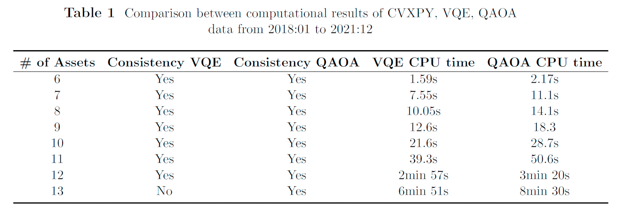

According to our experiment results, we can conclude that the quantum algorithms have acceptable computational consistency on binary portfolio optimization problems, however, since classical computers cannot simulate the real quantum circuits, the advantage of speed of quantum computing is unable to be shown in our experiment. Therefore, the next step of investigation is to run our experiment on a real qubit system (e.g. D-Wave quantum annealer).

1. **Options Pricing**. Derivative pricing is one of the most important financial applications in quantum computing. The classical mathematical methodology for derivative pricing uses techniques from stochastic calculus, and under the geometric Brownian motion model, the pricing formula of European call option is given by the so-called **Black-Scholes formula**. The most common numerical algorithm for derivative pricing is binomial tree approach, whose essence is using random walk under risk neutral measure to approximate geometric Brownian motion, namely, the sample path of stock price. And then, we can acquire the approximate price of the derivative. In quantum computing, the basic idea is similar to the binomial tree approach, where we want to construct a quantum circuit to simulate a log-normal distribution into a quantum circuit. For technical details, please refer to the technical document. The numerical results are in the Table below:

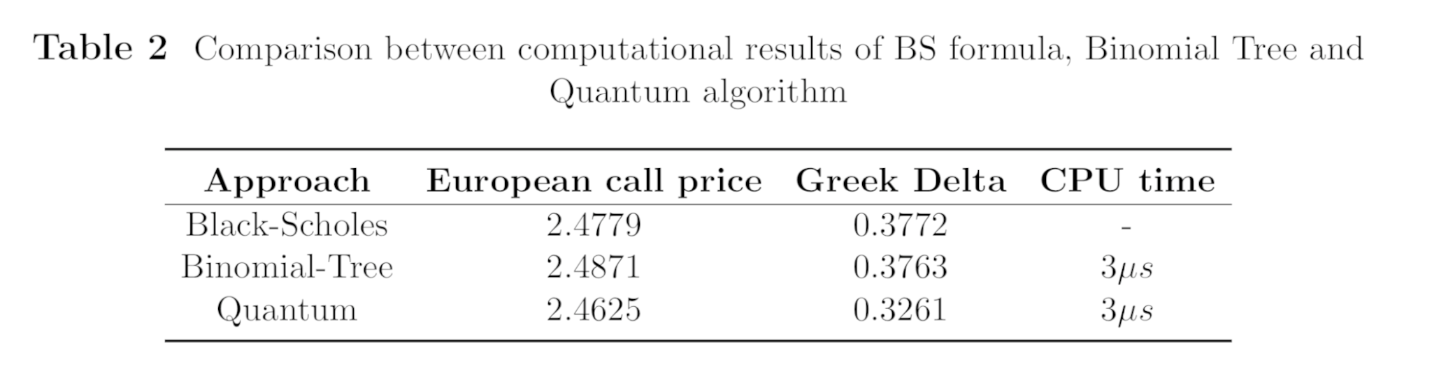

According to our experiment results, we can conclude that the quantum algorithms have acceptable computational consistency on derivative pricing problems. However, there exist quite many other risk analysis techniques and several other stochastic volatility models (e.g. SABR model, Heston model) popular in financial practice. The next step of the experiment is to move on to those more advanced problems.

1. **Linear PDE Solver**. We have started to explore the possible applications of quantum algorithms in solving partial differential equations (PDEs) arising in finance. Indeed, many pricing and hedging problems can be formulated as solutions to a PDE. A famous example is the Black-Scholes PDE for options pricing, whose closed-form solution is the Black-Scholes formula. We shall first investigate the linear PDE and then the more complicated nonlinear PDE, such as the **Hamilton-Jacobi-Bellman (HJB)** equations commonly appearing in optimal investment problems. The core part of quantum linear PDE solver is the **variational quantum algorithm**, which can be roughly represented by the following graph:

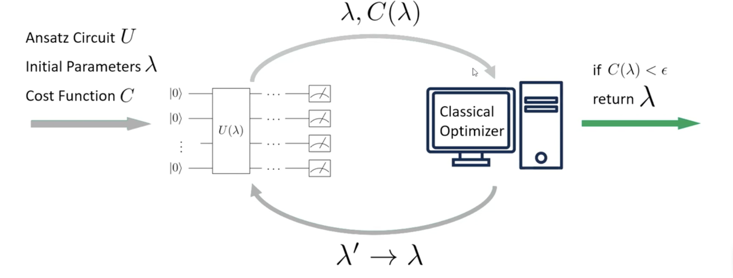

The technical details of the above graph is in the separate technical document. We are at the initial exploring stage and developing a quantum PDE solver for financial applications will be the next focus for our project.

# **Fall IAB Meeting - November 3 + 4, 2022 at Stevens Institute of Technology**

Presentation Topic for the IAB meeting:

Quantum Methods for Portfolio Optimization, Options Pricing and Solving Partial Differential Equations in Finance